Joshua del Pilar

ADB

Mini Thesis

December 10, 2020

ADB: Economic Activity & Climate Change

This study is a mini-thesis prepared for the Asian Development Bank, which was prepared for ADB’s scrutiny as part of a job application. The data u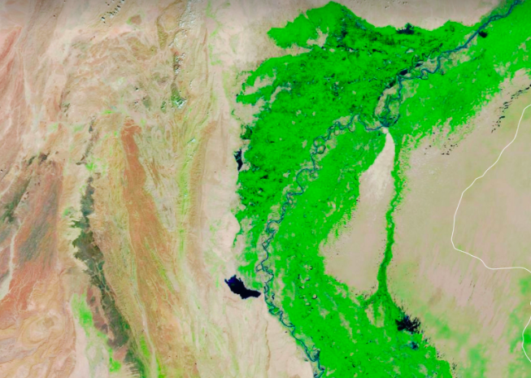sed in this study was obtained from the World Bank’s Open Data Set on Climate Change. This dataset is limited between 1990-to-2010, in which a decade of change might question the relevance of the present insights written below.

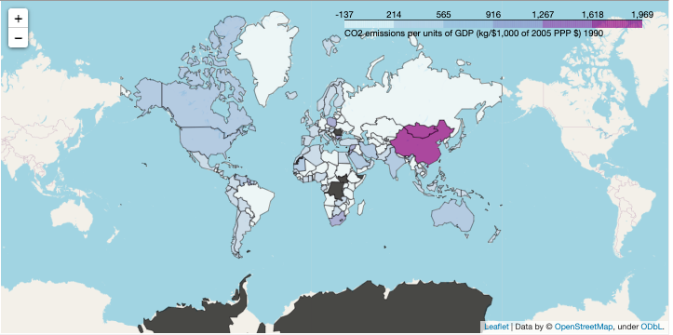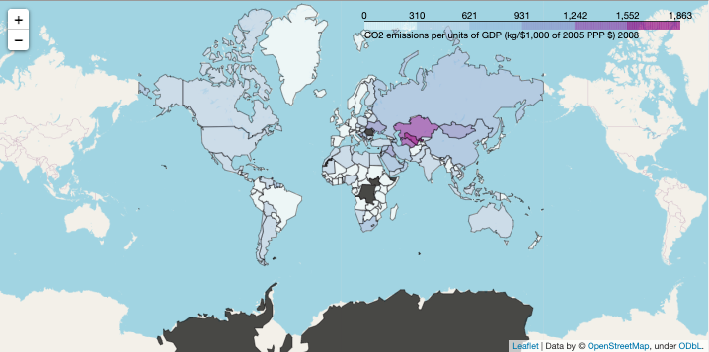**Current Climate Measures by DMCs**

“The science and economics of global warming are clear. Unless forceful measures are taken, the planet will continue to warm.”

- WIlliam Nordhaus

As we can see in the graph, the distribution of CO2 emissions in 1990 is polarized to China—notably being the largest emissions contributor, roughly twice the US. But there has been a dramatic realignment in CO2 emissions during 2008—with China matching transatlantic levels.

The main dilemma between the issue of climate change and economic activity is what measures must take place without stifling DMC economies. These measures must be aligned with the Sustainable Development Goals (SDGs). Currently, the most sensible measure is to fully transition towards carbon-free energy.

With the COVID-19 pandemic, DMC economies’ struggles have been exacerbated. But some developing countries have been able to alleviate the pandemic’s costs—such as Bhutan and Vietnam. Nevertheless, the pandemic has slowed consumption of fossil fuels, allowing DMCs (especially with high levels of emissions) to realign their energy consumption towards renewables.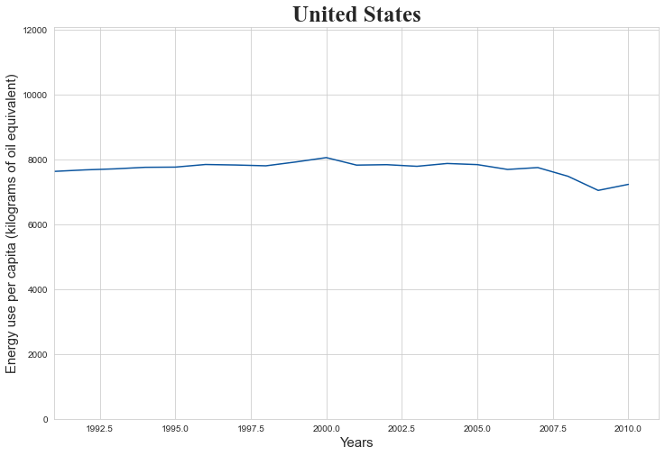

Lessons from G20 Nations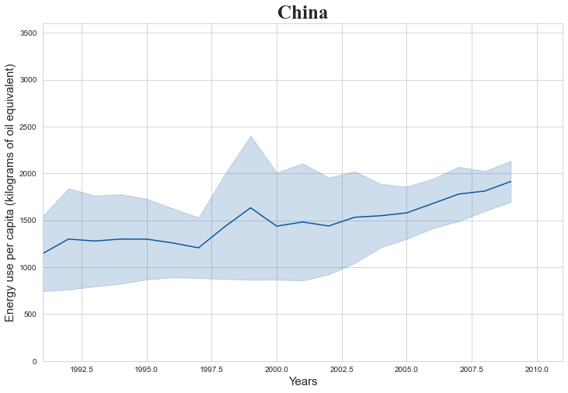

In the United States, the Energy Innovation and Carbon Dividend Act (EICDA) was proposed to congress. The act establishes a fee on each ton of greenhouse gas emissions. A study by the Center on Global Energy Policy notes that net government revenue declines and energy prices are set to rise slightly, the effects of GHG emissions air pollution decline outweigh the initial costs. Furthermore, the revenue gained by the carbon tax will support low-income households and even support other fiscal interventions. Considering that the United States, over the past two decades have been consuming more energy—two-fold compared to China—shows that this energy intensive economy is ready to transition.

Immediate Practical Steps

In the area of climate policy, there are two approaches towards developing a climate-action framework: mitigation and adaptation. Currently, global and domestic policies are centered on mitigation, with a focus on lowering carbon emissions and transitioning to clean energy. The immediate steps that development banks and member governments can do are:

* Provide loans assistance to emerging energy companies
* Provide bonds for Green Infrastructure
* Support the innovation economy for developing the energy industry further
* Upgrading Agriculture & Land Use
* Emissions Accountability

Loans assistance and green bonds are already at the policy toolkit of many governments and development banks. But putting more emphasis in these areas may accelerate the energy transition. Also, by supporting the innovation economy, and promoting the innovation ecosystem, market competition in the energy industry will promote the development of viable energy technologies that can accelerate SGD no. 17 (affordable and clean energy). Based on a Brookings report, agriculture and land use accounts for about 24% of global emissions (Victor et al., 2019, p. 14). New emerging technologies and methods in agriculture—most notably Controlled Environment Agriculture and Vertical Farming—can lower carbon emissions, whilst preserving and even promoting food security; developments in this area can be supported by promoting the innovation economy. Lastly, by introducing climate litigation, both public and private entities can be held accountable for breaches in climate policies. Enforcement would then promote the sustainability of the world’s, and DMCs’ climate-related efforts.

References:

Asian Development Bank (December 2020). Climate Change, Coming Soon To A Court Near You: Climate Litigation in Asia and the Pacific and Beyond. Mandaluyong: Asian Development Bank. http://dx.doi.org/10.22617/TCS200027-2

Victor, D.G., Geels, F.W., Sharpe, S. (November 2019). Accelerating the Low Carbon Transition: The case for stronger, more targeted and coordinated international action. Brookings Institution.

Kaufman, N., Larsen, J., Marsters, P., Kolus, H., Mohan, S. (October 2019). As Assessment of the Energy Innovation and Carbon Dividend Act. The Center on Global Energy Policy.

COVID-19 Policy Research Task Force. (August 2020). Shadows of COVID-19: The Developing World and East Asia’s Response. Reischauer Center for East Asian Studies, Johns Hopkins University SAIS.

Nordhaus, W. (2013). The Climate Casino: Risk, Uncertainty, and Economics for a Warming World. Yale University Press.